**[Click here to access the Student Navigator.](https://navigator.clf.uk/JCA/Students/index.html" \l "gsc.tab=0)** The student navigator page contains links to all the pages you will need if you are learning from home.

[**Click here to access a guide to INSIGHT**](https://clfacademies-my.sharepoint.com/:b:/g/personal/patrick_bolton_clf_uk/EbhMioLl4btPtlPuXZUUUJwBtulZyKuG2WdF9qY1vlRMOA?e=O5E3dJ), our student information system.

Contents

Key Dates 1

Principal’s message 2

JCA Routines – Uniform 2

Parent Survey 5

What Will My Child be Learning in September? 6

World Book Day 6

JCA Fantasy Football 9

Digitech Studio Schools 10

Knife Crime Booklet for Parents 11

# Key Dates

|  |  |
| --- | --- |
| 4th September  5th September  6th September  7th September  14th September  29th September  29th September  3rd October  5th October  9th 18th - October  12th October  17th October  18th October  19th October  20th October  23rd – 27th October  30th October | INSET DAY – School Closed to Pupils  Year 7 only, School Closed to Other Pupils  All Pupils in School  Year 7 School Photos  JCA Open Evening – School Finishing 14:40 to Pupils  Year 11 Parents Evening  Academy Council  DofE Expedition  UKMT Senior Maths  Netball and Football Tour Parents Evening  Nasal Flu Immunisation  Year 11 Mock Exams  Anti-Bullying Working Group  Acoustic Night  Year 7 Meet the Tutor Evening  CLF INSET Day – School Closed to Pupils  CLF INSET Day – School Closed to Pupils  Half Term – School Closed  First Day Back of Term 2 |

# Principal’s message

KATE MESSAGE

In our vision for our Academy, we talk about Raising our Community together. As I reflect on the hectic last few weeks of this year, our students have fully embraced the opportunities on offer to contribute to our Academy life. Be it moving out of a flooded tent at mid-night whilst on camp without a single complaint, or performing on stage or be exemplary in their Year 10 mock exams. We could not be prouder of our community.

Thank you to you as parents, for all the support you too offer to our community. It is only be working together in support of our students that we can create such trusting and respectful relationships that allow your children an education to be proud of. I look forward to working ever more closely together next year (more below in the Parent Voice section) and I wish you a wonderful, relaxing summer holiday.

We look forward to seeing your child on:

Tuesday 5th September for Year 7

Wednesday 6th September for Years 8, 9, 10 and 11.

Kate Willis

**Principal**

# JCA Routines – Uniform

Our students look really smart in our uniform. Please do ensure your child(ren) have the correct uniform both for PE and for normal lessons.

Wearing a uniform helps all of us to feel part of a wider community of which we are all proud to be part. Students not in the correct uniform will spend time in the SLR if they are unable to borrow the right piece and this is not the way we want our community to start the year. A reminder of our uniform expectations is below; please support us in being prepared for September.

**PE Kit**

 We only wear PE kit on our PE days. Student timetables will be shared on the first day back (Tuesday 5th September for Year 7 or Wednesday 6th September for all other year groups). Your child(ren) should attend that day in their normal school uniform.

**PE Days Academic Year 2023-2024**

Year 7: Thursday, Friday

Year 8: Monday (Y), Wednesday (X), Friday

Year 9: Monday (X), Tuesday, Wednesday (Y)

Year 10: Tuesday (X), Thursday (Y)

Year 11: Monday (X), Wednesday (Y)

**Outer layers:**

 Students are not able to wear outer layers when inside the school building.  This means that students, should they wish to wear anything over their shirt and tie or PE top, must have one of the following:

School blazer

School jumper

PE hoodie (these may be worn over ‘regular’ school uniform as well as over PE kit).

Please do ensure your child/children have at least one of the above that fits them.  Any concerns, please do contact the pastoral team.

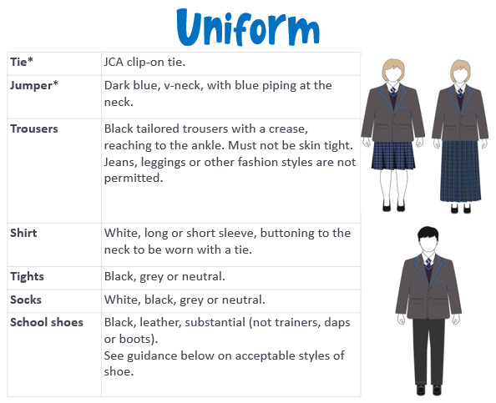

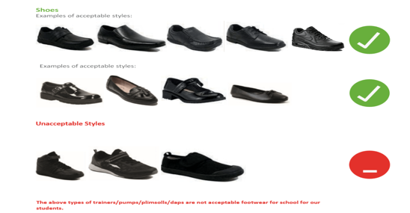

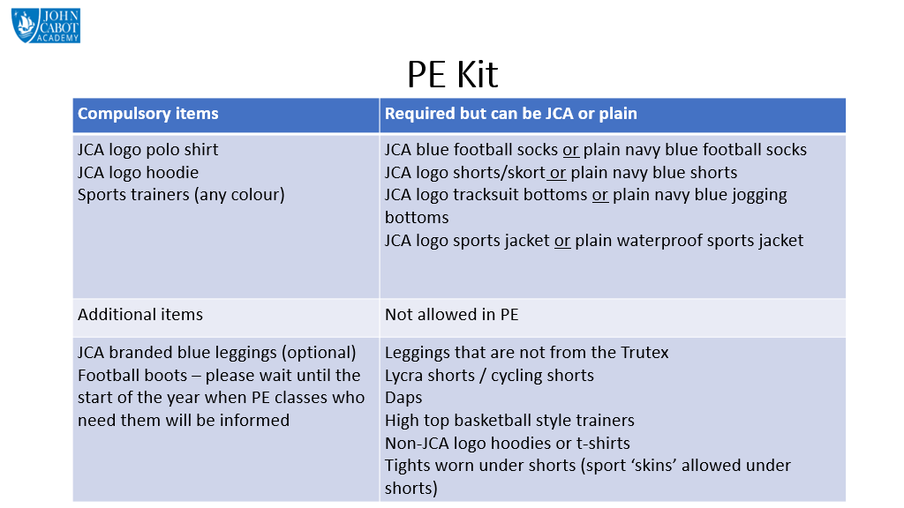

Kind regards

Gemma Read

**Vice Principal**

# Parent Survey

Thank you to the 150 parents who completed the online survey. There are some wonderful things to celebrate about our Academy and it has given me a clear picture of the areas we can work on together next year.

One of the key areas that Ofsted asked us to work on, back in November 2018, was communication with Parents and Carers. After our Staff-Parent working party and the launch of our communications policy in January 2020, it is really pleasing to see that the majority of parents feel:

* Welcome in our school and respected
* They can easily contact the school
* Well informed about your child's academic progress, homework, behaviour, attendance, punctuality
* That the reports are easily understood
* That the language we use is easily understood
* It is easy to contact the Academy
* It is easy to discuss complex issues with the school
* That parents' evenings are useful
* That the weekly newsletter is very useful

Our school vision is to nurture the individual children and inspire them in their learning. Therefore I am really pleased that the majority of parents feel that our approach to lessons, marking, behaviour, attendance and homework meet your child's needs. Also that you feel our teachers help your child to learn, keep them safe and treat them fairly. That you feel you clearly understand what the school expects of you as a parent and how to ask for advice. And thus feel confident about your child's progress at school.

The key area you wanted us to work on was more engagement with parents. So next year, I want to set up an ongoing working party with a group of parents who can help us solve some of the areas in the survey for example: help parents feel informed about how their child is doing socially. More information on this will follow in September.

There will be some changes next year based on your feedback. Parents' evenings will move back to in-person. While many parents are happy with the online version, there is a significant minority who cannot access them online at all and so miss out entirely.

Apps. By moving to a new database, we will be able to combine the number of apps over time into just one. Just bear with us, we will need to do this over the course of next year.

More communication with year 10 & 11 parents about their child's progress in their coursework over the course of their GCSEs.

Kate Willis

**Principal**

# What Will My Child be Learning in September?

<https://johncabotacademy.clf.uk/curriculum-statement/>

On this page of the website, you will find the full curriculum plans for every subject for every year group throughout the year.

# World Book Day

We ran the Summer Book Bingo competition again and students can return their completed bingo cards to the library with the books they read by 13th September. Every 5 completed squares earns 1 entry to the prize draw, which will be for a book lovers reading bundle - prizes in the past have typically been a bookish pin badges, coffee mug, hot chocolate, biscuits, bookmarks, etc.

Please check shelves, under sofas, and inside old school bags at home for any library books. No matter how long they've been on loan the library will be grateful for all returned overdue books. Students are definitely welcome to borrow books over the summer holidays and now is a great time to stock up on new library loans.

Laura Harnell

**Librarian​**

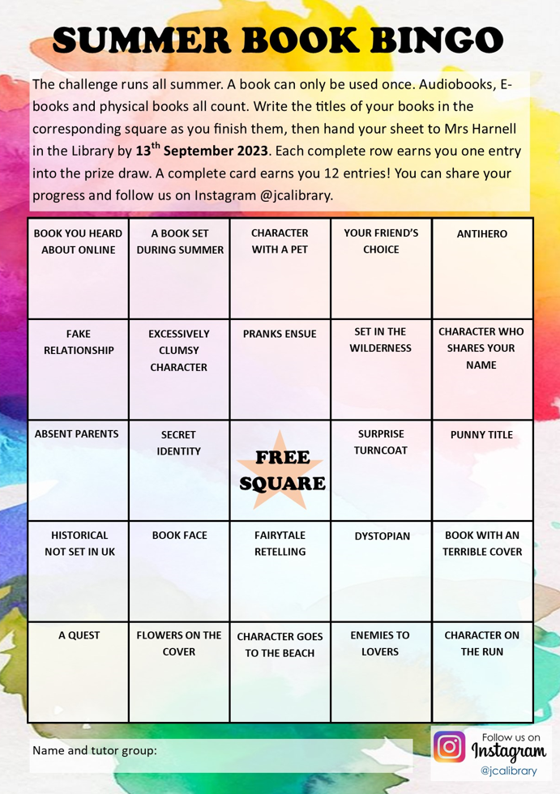

# JCA Fantasy Football

This academic year we are introducing a pupil / staff Fantasy Football league for KS4 pupils, the instructions for setting this up are included on the poster below. Fantasy Football gives people the opportunity to problem solve, manage a virtual budget, make tactical decisions and be part of a community. During September, KS4 pupils will be given a code to join the league where they can enjoy some friendly competition between each other as well as staff

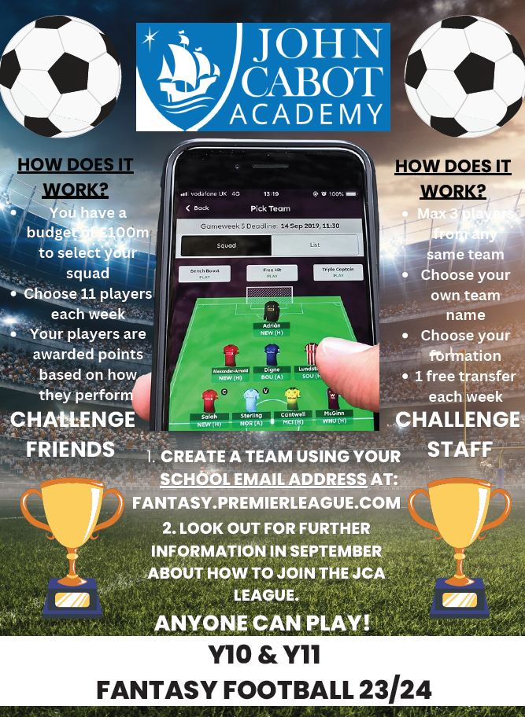

# Digitech Studio Schools



# Knife Crime Booklet for Parents

Dear Headteacher & Safeguarding Lead,

As you will be aware, this term has sadly seen the death of a South Gloucestershire school pupil in tragic circumstances. This has had a devastating impact on other students, staff, parents and those working in children’s services.

We are working with Avon and Somerset police and other partners to support schools at this difficult time and we will continue this support as we move forward into the new academic year.

As part of this, we have put together a package of resources which you may find helpful to share with your staff, students or parents as appropriate. This includes the attached booklet designed for parents and carers of young people to help them start conversations about knife crime and the dangers of carrying a bladed weapon. It also provides links and contacts for further support.

The information has been put together courtesy of the Ben Kinsella Trust, a charity which works to educate young people on the dangers of knife crime and help them to make positive choices to stay safe. We are grateful to the trust, and the Office for the Police and Crime Commissioner in Avon and Somerset, for allowing and helping us to produce this booklet for our schools.

A digital copy of the booklet is available at [www.southglos.gov.uk/violence-reduction-partnership/](https://protect-eu.mimecast.com/s/Wos_CB1vKSZqLPfzxCzd?domain=southglos.gov.uk/)

If you have any queries about the information in the booklet or require any additional resources in relation to knife crime and serious violence, please contact 01454 868751 or email [communitysafetyteam@southglos.gov.uk](mailto:communitysafetyteam@southglos.gov.uk)

We hope you find the booklet helpful.

Kind regards,

**Lynda Cordukes**  
Safeguarding Education Advisor

Department for People   
South Gloucestershire Council  
T: 01454 86 3167  
[www.southglos.gov.uk](https://protect-eu.mimecast.com/s/bqhuCEKyNFAyZ1spXVoa?domain=southglos.gov.uk/)

   